# Ideation Phase Empathize & Discover

|  |  |
| --- | --- |
| Date | 08 September 2022 |
| Team ID | PNT2022TMID31883 |
| Project Name | Project - Smart Waste Management System For Metropolitan Cities |
| Maximum Marks | 4 Marks |

## Empathy Map Canvas:

An empathy map is a simple, easy-to-digest visual that captures knowledge about a user’s

behaviours and attitudes

It is a useful tool to helps teams better understand their users.

Creating an effective solution requires understanding the true problem and the person who is experiencing it. The exercise of creating the map helps participants consider things from

the user’s perspective along with his or her goals and challenges.

# Example:

**EMPATHY MAP**

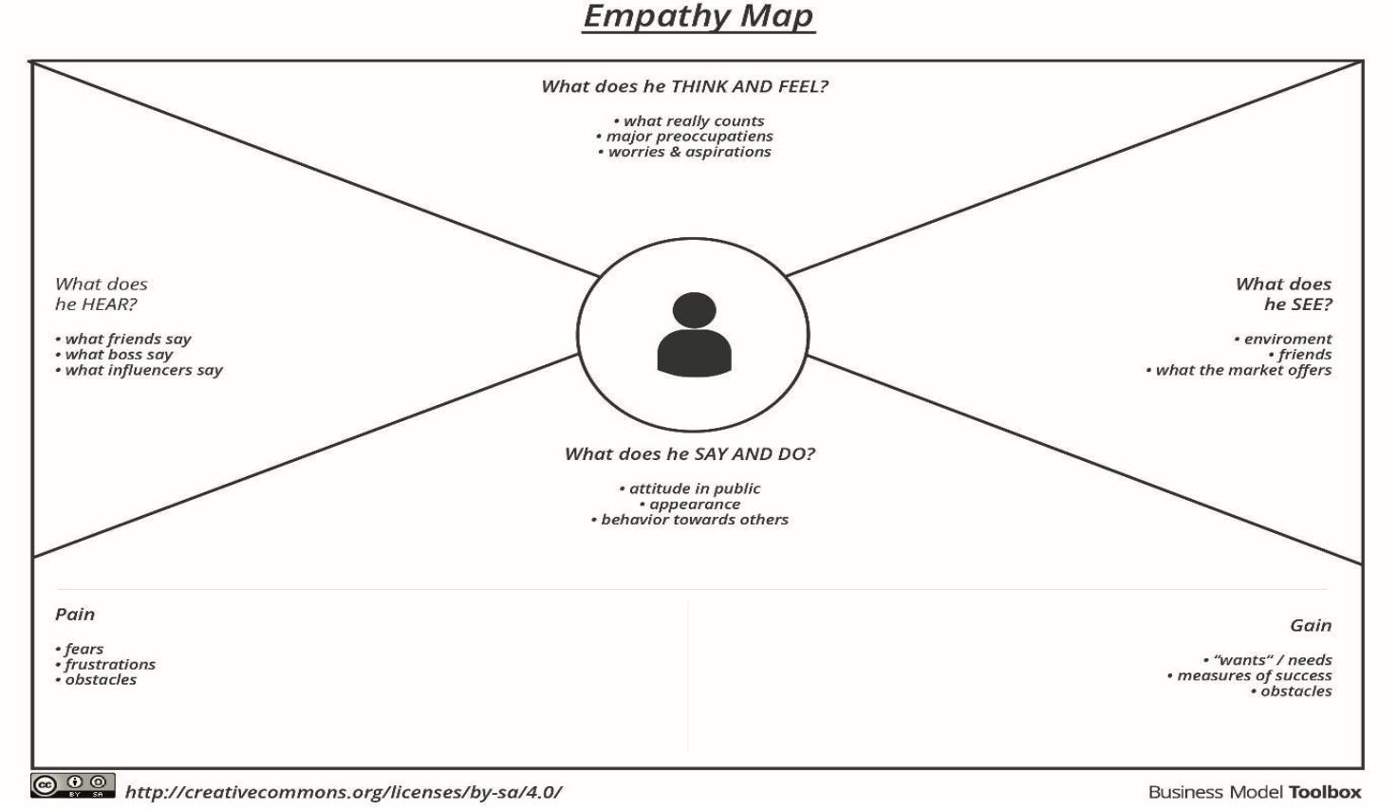

## SMART WASTE MANAGEMENT SYSTEM USING IOT

